|  |  |  |  |  |
| --- | --- | --- | --- | --- |
|  |  | | |  |
|  |  | | |  |
|  | Function Group Spec  Near Field Communication  Custom Scope | | |  |
|  |  |
|  |  |
|  |  | | |  |
| Document Type | **Function Specification** | | |  |
| Template Version | **6.0** | | |  |
| SysML Report Template Version | **M (4/16/2019)** | | |  |
| Document ID | **2020-08-24** | | |  |
| Document Location |  | | |  |
| Document Owner | **Aaron Bonnell-Kangas (abonnel1)**  **Farhan Ehsan (fehsan1)**  **Eugene Karpinsky (ekarpins)** | | |  |
| Document Revision | **2020-08-24 (P708 UPV1)** | | |  |
| Document Status | **Draft** | | |  |
| Date Issued | **2020-05-22** | | |  |
| Date Revised | **2020-08-24** | | |  |
| Document Classification | GIS1 Item Number: | **27.60/35** | |  |
| GIS2 Classification: | **Confidential** | |
|  | | | | |
|  | | | | |
| Document Approval | | | | |
| Name | Role | | Email Confirmation | Date |
|  |  | |  |  |
|  |  | |  |  |

Auto-Generated by MagicDraw

Printed Copies are Uncontrolled

# Disclaimer

**This document contains Ford Motor Company Confidential information. Disclosure of the information contained in any portion of this document is not permitted without the expressed, written consent of a duly authorized representative of Ford Motor Company, Dearborn, Michigan, U.S.A.**

**Copyright, Ó 2020 Ford Motor Company**

This document contains information developed and accumulated by and for FORD MOTOR COMPANY. As such, it is a proprietary document, which, if disseminated to unauthorized persons, would provide others with restricted information, data, or procedures not otherwise available, exposing the FORD MOTOR COMPANY to potential harm.

Employees and suppliers having custody of this specification or authorized to use it must be cognizant of its proprietary nature and ensure that the information herein is not made available to unauthorized persons.

FORD MOTOR COMPANY reserves the right to protect this work as an unpublished copyrighted work in the event of an inadvertent or deliberate unauthorized publication. FORD MOTOR COMPANY also reserves its rights under copyright laws to protect this work as a published work.

This document or portions thereof shall not be distributed outside FORD MOTOR COMPANY without prior written consent. Refer all questions concerning disclosure to the author(s) or to any duly authorized representative of Ford Motor Company.

# Contents

Disclaimer 2

Contents 3

1 Introduction 4

1.1 Document Purpose 4

1.2 Document Audience 4

1.2.1 Stakeholder List 4

1.3 Document Organization 4

1.3.1 Document Context 4

1.3.2 Document Structure 4

1.4 Document Conventions 4

1.4.1 Terminology 4

1.4.2 Requirements Templates 5

2 Function Group Description 6

2.1 Logical System Properties 6

3 Operational modes and states 7

3.1 Display System 7

3.1.1 Display System states 7

3.1.2 Display System requirements 9

3.2 Add NFC key InnerSTM 16

3.2.1 Add NFC key InnerSTM states 18

3.2.2 Add NFC key InnerSTM requirements 18

3.3 MyKey Management Inner STM 21

3.3.1 MyKey Management Inner STM states 21

3.3.2 MyKey Management Inner STM requirements 22

3.4 Personal Profiles Linking STM 23

3.4.1 Personal Profiles Linking STM states 24

3.4.2 Personal Profiles Linking STM requirements 25

3.5 Remove NFC Key Inner STM 27

3.5.1 Remove NFC Key Inner STM states 28

3.5.2 Remove NFC Key Inner STM requirements 29

4 Revision History 31

5 Appendix 32

5.1 Data Dictionary 32

5.1.1 Logical Messages 32

5.1.2 Data Types (encodings) 40

**List of Figures**

Figure 1: Display System 7

Figure 2: Add NFC key InnerSTM 17

Figure 3: MyKey Management Inner STM 21

Figure 4: Personal Profiles Linking STM 24

Figure 5: Remove NFC Key Inner STM 28

**List of Tables**

Table 1: Operation Modes and States on Display System 9

Table 2: Operation Modes and States on Add NFC key InnerSTM 18

Table 3: Operation Modes and States on MyKey Management Inner STM 22

Table 4: Operation Modes and States on Personal Profiles Linking STM 25

Table 5: Operation Modes and States on Remove NFC Key Inner STM 29

# Introduction

## Document Purpose

The Function (Group) Specification (FS) specifies an individual function / a group of functions.

To get more information about the concept of feature, function and component level abstraction refer to the [Ford RE Wiki](http://wiki.ford.com/display/RequirementsEngineering/Requirements+Engineering+for+SW+Enabled+Features).

## Document Audience

The FS is authored by the owners of the individual functions. All Stakeholders, i.e., all people who have a valid interest in the functions and their behavior should read and, if possible, review the FS. It needs to be guaranteed, that all stakeholders have access to the currently valid version of the FS.

### Stakeholder List

For the latest list of the feature stakeholder and their roles & responsibilities refer to <Put VSEM Link here>.

|  |  |  |  |  |
| --- | --- | --- | --- | --- |
| **Name** | **CDSID** | **Org.** | **Title** | **Project Role** |
| John Van Wiemeersch | jvanviem | RA&E, Adv. Feat. Development | Supervisor | Design Support |
| Aaron DeLong | adelong2 | RA&E, Adv. Feat. Development | Research Engineer | Research Design Lead |
| Vivek Elangovan | velango5 | RA&E, Adv. Feat. Development | Research Engineer | Design Support |
| Rita Trupiano | mtrupia1 | PD, Sys. Eng.,  Distributed Feat. | Feature Owner Supervisor | Feature Owner Supervisor |
| Eugene Karpinsky | ekarpins | PD, Sys. Eng.,  Distributed Feat. | Core Feature Owner | Production Design Lead and Feature Owner |
| Farhan Ehsan | fehsan2 | PD, Sys. Eng.,  Distributed Feat. | Core Feature Owner | Production Design Lead and Feature Owner |
| Aaron Bonnell-kangas | Abonnel1 | PD, Sys. Eng.,  Distributed Feat. | Core Feature Owner | Production Design Lead and Feature Owner |
| Matt Swis | mswis | PD, EESE, Body & Security Elec. | Core Security & RF Supervisor | NFC System Owner Supervisor |
| Nisha Patel | npate152 | PD, EESE, Body & Security Elec. | Core NFC Engineer | NFC System Owner |
| David Hernandez | dhern138 | PD, EESE, Body & Security Elec. | Core NFC Engineer | NFC System Owner |
| Suthagaran Nagarasa | snagaras | PD, EESE, Body & Security Elec. | Core NFC Engineer | NFC System Owner |
| Kevin Hille | khille | PD, EESE, Body & DAT SW | Technical Specialist – Immob. | NFC Immobilizer Function Owner, Design Support |
| John Ricks | jricks7 | PD, EESE, Body & DAT SW | Software Supervisor | Software Supervisor |
| John Popovecz | jpopovec | PD, EESE, Body & DAT SW | Body Module SW Supervisor | Body Module SW Supervisor |
| Hosam Irsheid | hirsheid | PD, EESE, Body & DAT SW | Software Engineer | Software Design |
| Sam Mehdi | hmehdi | PD, EESE, Body & DAT SW | Product Design Engineer | Software Design |
| Vishala Pasala | vpasala | PD, EESE, Body & DAT SW | Software Engineer | Software Design |
| Maeen Mawari | mmawari | PD, EESE, Body & DAT SW | MBSE Engineer | Software Design |
| Eric Reed | ereed2 | PD, EESE, Body & DAT SW | VSC SW Engineer | Software Design |
| Ahmad Sabri | asabri3 | PD, EESE, Body & DAT SW | PD Engineer | Software Design |
| Jeff Lossing | jlossing | PD, EESE, Body & DAT SW | Software Engineer | Software Design |
| Andrew Hall | ahall185 | PD, EESE, Body & DAT SW | Design Engineer, BCM Software | Software Design |
| Sachin Magar | smagar | PD, EESE, Body & DAT SW | Design Engineer, BCM Software | Software Design |
| Akshita Kulkarni | akulka2 | PD, EESE, Body & DAT SW | Design Engineer, BCM Software | Software Design |
| Adithya Ramachandran | aramac11 | PD, EESE, Body & DAT SW | Software Engineer | Software Design |
| S Bagga | sbagga11 | PD, EESE, Body & DAT SW | Software Engineer | Software Design |
| Gail Cheng | gcheng | PD, In-Vehicle Infotainment & Connectivity | Infotainment Systems Supervisor | Infotainment System Design Supervisor |
| Matthew Borrelli | mborrel4 | PD, In-Vehicle Infotainment & Connectivity | Infotainment Systems Engineer | Infotainment System Design |
| Laura Check | lburek | PD, In-Vehicle Infotainment & Connectivity | SYNC Supervisor | SYNC System Supervisor |
| Iqbal Faheem Sayyed | isayyed | PD, In-Vehicle Infotainment & Connectivity | SYNC Technical Program Manager | SYNC Technical Program Manager |
| Scott Watkins | swatkins | PD, In-Vehicle Infotainment & Connectivity | DI Technical Expert | Driver Information Design Support |
| Stavros Dionyssopoulos | sdionyss | PD, CIED | DI HMI Engineer | Driver Information HMI Support |
| Nicholas Davio | ndavio | PD, CIED | HMI Supervisor | HMI Support Supervisor |
| Mack Dobbie | mdobbie | PD, CIED | HMI Designer | HMI Support |
| Montana Pruett | mpruett2 | PD, CIED | I&E Engineer | I&E Support |
| Patrick Brautigan | pbrautig | PD, CIED | UX Engineer | UX Support |
| Jeffrey Hamel | jhamel7 | PD, Enterprise Connectivity | Product Owner, TPM | Ford Mobile App Design |
| Michael Martinez | mmart664 | PD, Mobility | Product Manager | Ford Mobile App Design |
| Bruce Williams | bwilli28 | PD, EESE, Netcom Core | Product Design Engineer | Electrical Architecture Consult |
| Jim Lawlis | jlawlis | PD, EESE, Advanced Netcom | Technical Specialist - Netcom | Electrical Architecture Consult |
| Nhi Torres | ntorres5 | PD, EESE, Netcom Diag. | Supervisor | Electrical Architecture Consult |
| Eric Paton | epaton | PD, EESE, Netcom Diag. | Engineer | Electrical Architecture Consult |
| Ankita Vyas | avyas8 | PD, EESE, Functional Safety | Functional Safety Engineer | Functional Safety Consult |
| Juan Tejada | jtejeda6 | PD, EESE, MBSE | Modelling Expert | Modelling Support |
| Ahmet Cinar | acinar1 | PD Europe, Underbody EESE | Tech. Expert – Closure Electronics | Closure Design Consult |
| Uwe Zank | uzank | PD Europe, Underbody EESE | Supervisor, Security Electronics | Security Design Consult |
| Denney Vellaramkalayil | dvellara | PD Europe, Underbody EESE | System Engineer, Locking Application | Locking Design Support |
| Henry Popow | hpopow | Quality, EESE | Quality Engineer | Quality Coach |
| Gerard Szczepaniak | gszczepa | Quality, EESE | Quality Engineer | Quality Coach |
| Christina Bloxsom | cbloxsom | SE&SE, ASO, Adv. Policy | Subject Matter Expert | Safety & Regulations Consult |
| Mike Westra | mwestra | IT, Cybersecurity | Technical Leader – Security | Cybersecurity Consult |
| Jochen Schubert | jschub1 | IT, Cybersecurity | Cybersecurity Engineer | Cybersecurity Design Support |
| Dan Zajac | dzajac8 | IT, Cybersecurity | Cybersecurity Supervisor | Cybersecurity Supervisor |
| Jacob Nelson | jnels148 | IT, Cybersecurity | Cybersecurity Engineer | Cybersecurity Design Support |
| Xin Ye | xye7 | IT, Cybersecurity | Technical Specialist - Security | Cybersecurity Consult |
| Simon Hurr | shurr | IT, Cybersecurity | Security Application Specialist | Cybersecurity Consult |
| Mike Simons | msimon78 | IT, CVP&P, PaaK | Systems Engineer | Off Board Function Owner Lead |
| Faten Fawaz | ffawaz | IT, CVP&P, Basic Design | Basic Design Architect | Backend Infrastructure Design Lead |
| Steve Craig | scraig33 | IT, CVP&P, Integration | Technical Program Manager | Backend Infrastructure Design Support |
| Yona Shaposhnik | yshaposh | IT, MPS, Mobility Arch. | Solution Architect | Backend Infrastructure Design Support |
| Michelle Moody | mmoody1 | IT, Mobility, FCS | Director | Project Champion – Fleet |
| Robert Johnson | rjohns75 | IT, Mobility, FCS | Product Marketing Manager | Project Champion – Fleet |
| Mustapha Elkhatib | melkhat1 | IT, Mobility, FCS | Product Manager | Fleet Infrastructure Design Support |
| Geoffrey Scofield | gscofiel | IT, Mobility, FCS | Product Engineer | Fleet Infrastructure Design Support |
| Jennifer Oak | joak | MS&S, US Marketing | Connected Marketing Manager | Project Champion – Retail |
| Timothy Son Hing | tsonhin1 | MS&S, US Marketing | Marketing Manager | Project Champion – Retail |

## Document Organization

### Document Context

Refer to the [Specification Structure page](http://wiki.ford.com/display/RequirementsEngineering/Specification+templates) in the [Ford RE Wiki](http://wiki.ford.com/display/RequirementsEngineering/Requirements+Engineering+for+SW+Enabled+Features) to understand how the FS relates to other Ford Requirements Documents and Specifications.

### Document Structure

The structure of this document is explained below:

**Section 1** – Introduction how to use this document including responsibilities and requisite documents. Explains the tterminology. Gives a clarification of the definitions, concepts and abbreviations used in the document.

**Section 2** – Function Group Description. Gives an overview and the purpose of the function group.

**Section 3** – Functional Architecture: Specifies the overall functional architecture of the function group

**Section 4** – Function Specifications: Specifies the logical functions of the function group in detail

**Section 5** – List of Open Concerns

**Section 6** Revision history including a list of new or modified requirements. The requirements in this document are tagged, and this section contains different types of tables listing all, new, or changed requirements by their title and page no.

**Section 7** – Appendix: Presenting additional data mainly in a tabular form, e.g., a data dictionary

## Document Conventions

### Terminology

When referring to aspects of the system design, this document uses standardized language to avoid ambiguity and confusion. The following terms are of particular relevance to this document:

|  |  |
| --- | --- |
| **Term** | **Definition** |
| Configuration parameter | A property of a system that is stored in nonvolatile memory and not expected to be changed during system operation. Examples include assigned serial numbers that are unique to each module and static. |
| Runtime variable | A property of a system that can be read and modified during normal system operation. The variable might be stored in volatile or nonvolatile memory. Examples include stored/saved records, system states, and measured values. |
| Message | A message defines a data structure whose elements are all transmitted simultaneously. The message might be transmitted within a single system, or across a network between two separate systems.  The term “message” is used here to reduce confusion when discussing automotive system behaviors. As it is used in this document, a “message” is identical to the concept of a “signal” as defined in UML/SysML.  A message may or may not contain *signals* – see below. |
| Signal | A signal is a single data element within a message. A signal cannot be transmitted independently of a message, but a message can be transmitted without any signals.  As it is used in this document, a signal corresponds to the UML/SysML concept of a *property*. |

### Requirements Templates

Each requirement, use case or scenario in this specification shall follow the corresponding template given in the document template *Specification_Macros.dotm* at [RE Wiki - Specification Templates](http://wiki.ford.com/display/RequirementsEngineering/Specification+templates?src=contextnavpagetreemode).

#### Identification of Requirements

#### Requirements Attributes

The templates provided by *Specification_Macros.dotm* define a list of attributes for each requirement. This helps to classify the requirement. The attributes are explained at [RE Wiki - Requirements Attributes](http://wiki.ford.com/display/RequirementsEngineering/Requirements+Attributes?src=contextnavpagetreemode).

# Function Group Description

This Function Group consists of documentation about the logical system component -530348061.png **Center Stack Display System.**.

## Logical System Properties

#### Configuration Parameters

|  |  |  |
| --- | --- | --- |
| **Parameter name** | **Data type** | **Description** |
| MyKey Creation Body Control System Response Timeout | period duration | The duration that the Display System will wait to receive a response from the Body Control System indicating that it is ready/allowing for MyKey creation  Default value = 30 seconds |
| NFC fleet management active | Boolean | Active = Vehicle is enrolled in "NFC Fleet Management" subscription  Inactive = Vehicle is not enrolled in "NFC Fleet Management" subscription |
| NFC enabled | Boolean | Enabled = Display System NFC feature related behaviors, screens, and pop-ups are enabled  Disabled = Display System NFC feature related behaviors, screens, and pop-ups are disabled |

# Operational modes and states

## Display System

The screens and flows of the in-vehicle display system that are relevant to the NFC Entry and Starting feature.

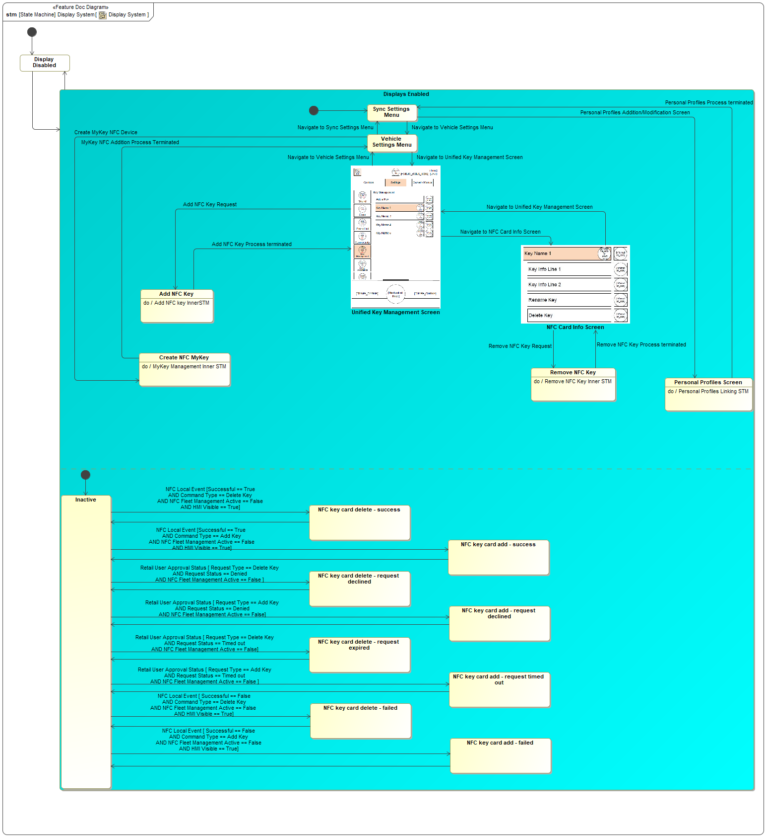

Figure 1: Display System

### Display System states

|  |  |
| --- | --- |
| **State** | **Requirements Reference** (optional) |
| Add NFC Key |  |
| Create NFC MyKey | * ID=REQ-NFC-ES-172 : Enable NFC MyKey Softbuttons |
| Display Disabled |  |
| Displays Enabled |  |
| Inactive |  |
| NFC Card Info Screen | * ID=REQ-NFC-ES-4 : NFC Card Info Screen * ID=REQ-NFC-ES-149 : NFC key management functions - not available if vehicle is subscribed to fleet NFC management * ID=REQ-NFC-ES-171 : Display System: Conditions to allow "Delete Key" for NFC Card Info Screen to be enabled * ID=REQ-NFC-ES-238 : Key Info Screen for Fleet vehicles * ID=REQ-NFC-ES-239 : Key Info Screen while MyKey in-use * ID=REQ-NFC-ES-240 : Key Info Screen for NFC Device used to start the vehicle * ID=REQ-NFC-ES-241 : Key Info Screen for "Factory" Card * ID=REQ-NFC-ES-242 : Display System: Conditions to allow "Delete Key" for NFC Card Info Screen to be enabled |
| NFC key card add - failed | * ID=REQ-NFC-ES-79 : Store NFC notifications for next vehicle start * ID=REQ-NFC-ES-143 : NFC key management notifications - no notifications if vehicle is managed by fleet * ID=REQ-NFC-ES-156 : Key add failure pop-up verbiage * ID=REQ-NFC-ES-210 : Show pop-up on key add failure * ID=REQ-NFC-ES-173 : Transmit Driver Information Message = "OK to Drive" on transition |
| NFC key card add - request declined | * ID=REQ-NFC-ES-79 : Store NFC notifications for next vehicle start * ID=REQ-NFC-ES-143 : NFC key management notifications - no notifications if vehicle is managed by fleet * ID=REQ-NFC-ES-160 : Content of key add request denial pop-up * ID=REQ-NFC-ES-214 : Show pop-up on key add request denial |
| NFC key card add - request timed out | * ID=REQ-NFC-ES-79 : Store NFC notifications for next vehicle start * ID=REQ-NFC-ES-143 : NFC key management notifications - no notifications if vehicle is managed by fleet * ID=REQ-NFC-ES-162 : Content of key add request expiration pop-up * ID=REQ-NFC-ES-216 : Show pop-up on key add request expiration |
| NFC key card add - success | * ID=REQ-NFC-ES-79 : Store NFC notifications for next vehicle start * ID=REQ-NFC-ES-143 : NFC key management notifications - no notifications if vehicle is managed by fleet * ID=REQ-NFC-ES-157 : Content of key add success pop-up * ID=REQ-NFC-ES-211 : Show pop-up on key add success |
| NFC key card delete - failed | * ID=REQ-NFC-ES-79 : Store NFC notifications for next vehicle start * ID=REQ-NFC-ES-143 : NFC key management notifications - no notifications if vehicle is managed by fleet * ID=REQ-NFC-ES-158 : Content of key delete failure pop-up * ID=REQ-NFC-ES-168 : Display System: Error screen after user confirms NFC Key Card Delete request * ID=REQ-NFC-ES-212 : Show pop-up on key delete failure |
| NFC key card delete - request declined | * ID=REQ-NFC-ES-79 : Store NFC notifications for next vehicle start * ID=REQ-NFC-ES-143 : NFC key management notifications - no notifications if vehicle is managed by fleet * ID=REQ-NFC-ES-161 : Content of key delete request denial pop-up * ID=REQ-NFC-ES-167 : Transmit Driver Information Message = "NULL" on transition * ID=REQ-NFC-ES-215 : Show pop-up on key delete request denial |
| NFC key card delete - request expired | * ID=REQ-NFC-ES-79 : Store NFC notifications for next vehicle start * ID=REQ-NFC-ES-143 : NFC key management notifications - no notifications if vehicle is managed by fleet * ID=REQ-NFC-ES-163 : Content of key delete request expiration pop-up * ID=REQ-NFC-ES-217 : Show pop-up on key delete request expiration |
| NFC key card delete - success | * ID=REQ-NFC-ES-79 : Store NFC notifications for next vehicle start * ID=REQ-NFC-ES-143 : NFC key management notifications - no notifications if vehicle is managed by fleet * ID=REQ-NFC-ES-159 : Content of key delete success pop-up * ID=REQ-NFC-ES-213 : Show pop-up on key delete success |
| Personal Profiles Screen | * ID=REQ-NFC-ES-197 : NFC Personal Profile Pairing process consistency |
| Remove NFC Key | * ID=REQ-NFC-ES-165 : Display System: Initiating NFC Key Deletion flow * ID=REQ-NFC-ES-169 : Display System: Provide "Request Screen" when NFC Key Deletion is requested |
| Sync Settings Menu |  |
| Unified Key Management Screen | * ID=REQ-NFC-ES-149 : NFC key management functions - not available if vehicle is subscribed to fleet NFC management * ID=REQ-NFC-ES-155 : Conditions to Enable "Add a Key" Button on Unified Key Management Screen * ID=REQ-NFC-ES-236 : Unified Key Management Screen for Fleet vehicles * ID=REQ-NFC-ES-237 : Unified Key Management Screen while MyKey in-use |
| Vehicle Settings Menu | * ID=REQ-NFC-ES-235 : Hide MyKey Creation Menu and related soft buttons for Fleet vehicles |

Table 1: Operation Modes and States on Display System

### Display System requirements

REQ-NFC-ES-4 NFC Card Info Screen

The NFC Card Info Screen shall display the following for each NFC Card:

Brief summary of how to use/scan the NFC Card

Specific NFC Card's FESN (maximum 8 characters)

The location of the FESN on the NFC Card

REQ-NFC-ES-79 Store NFC notifications for next vehicle start

When an NFC Command Complete Event or Retail User Approval Status signal is received that would cause a pop-up while the Sync system isn't fully operational/awake, the In-Vehicle HMI System shall display the modal immediately at the moment it is fully operational/awake .

REQ-NFC-ES-143 NFC key management notifications - no notifications if vehicle is managed by fleet

When the Display System's "NFC Fleet Management Active" configuration parameter is "True", then the Display System shall disable all pop-up notifications related to successfully adding or deleting devices from the vehicle

REQ-NFC-ES-149 NFC key management functions - not available if vehicle is subscribed to fleet NFC management

When the Display System's "NFC Fleet Management Active" configuration parameter is "True", then the Display System shall disable the "Add NFC Device" and "Delete NFC Device" related soft buttons

REQ-NFC-ES-155 Conditions to Enable "Add a Key" Button on Unified Key Management Screen

When the "NFC Enabled on System" configuration parameter of the Display System is "True" and "NFC Fleet Management Active" configuration parameter is "False", the "Unified Key Management" screen shall include the "Add a Key" button.

**Rationale**: This button allows the user to initiate adding an NFC card to the vehicle.

REQ-NFC-ES-156 Key add failure pop-up verbiage

The Display System shall have an NFC Feature related center-stack pop-up to indicate a system error at the time of adding an NFC Device, which includes:

- Reason text: "NFC Key Card Add Failed"

- The FESN or Friendly name of the selected NFC Key Card

**Rationale**: This notification is shown in the error case where the vehicle owner has approved a pairing, but a system error onboard the vehicle prevented the pairing from being completed. The FESN should be included because multiple card requests can be pending simultaneously - the FESN uniquely identifies the card that is the subject of the notification.

REQ-NFC-ES-157 Content of key add success pop-up

The Display System shall have an NFC Feature related center-stack pop-up to indicate successful adding an NFC Device, which includes:

- Reason text: "NFC Key Card Add Successful"

- The FESN or Friendly name of the selected NFC Key Card

**Rationale**: This notification lets the user know that the card is ready for use in the vehicle. The FESN should be included because multiple card requests can be pending simultaneously - the FESN uniquely identifies the card that has been added.

REQ-NFC-ES-158 Content of key delete failure pop-up

The Display System shall have an NFC Feature related center-stack pop-up to indicate a system error at the time of deleting an NFC Device, which includes:

- Reason text: "NFC Key Card Delete Failed"

- The FESN or Friendly name of the selected NFC Key Card

**Rationale**: This notification is shown in the error case where the vehicle owner has approved an unpairing, but a system error onboard the vehicle prevented the unpairing from being completed. The FESN should be included because multiple card requests can be pending simultaneously - the FESN uniquely identifies the card that has been added

REQ-NFC-ES-159 Content of key delete success pop-up

The Display System shall have an NFC Feature related center-stack pop-up to indicate successful deletion of an NFC Device, which includes:

- Reason text: "NFC Key Card Delete Successful"

- The FESN or Friendly name of the selected NFC Key Card

REQ-NFC-ES-160 Content of key add request denial pop-up

The Display System shall have an NFC Feature related center-stack pop-up to indicate the admin has denied the NFC Key Add request which includes:

- Reason text: "NFC Key Card Add Request Denied"

- The FESN or Friendly name of the selected NFC Key Card

**Rationale**: This notification is shown in the case where the vehicle owner has explicitly denied a request to add a key. The card is not usable to enter and start the vehicle.

The FESN should be included because multiple card requests can be pending simultaneously - the FESN uniquely identifies the card that is the subject of the notification.

REQ-NFC-ES-161 Content of key delete request denial pop-up

The Display System shall have an NFC Feature related center-stack pop-up to indicate the admin has denied the NFC Key Delete request which includes:

- Reason text: "NFC Key Card Delete Request Denied"

- The FESN or Friendly name of the selected NFC Key Card

**Rationale**: This notification is shown in the case where the vehicle owner has explicitly denied a request to unpair a key. The card is still usable to enter and start the vehicle.

The FESN should be included because multiple card requests can be pending simultaneously - the FESN uniquely identifies the card that is the subject of the notification.

REQ-NFC-ES-162 Content of key add request expiration pop-up

The Display System shall have an NFC Feature related center-stack pop-up to indicate the admin did not respond to the NFC Key Add request within a specific time frame, which includes:

- Reason text: "NFC Key Card Add Request Timed Out"

- The FESN or Friendly name of the selected NFC Key Card

**Rationale**: This notification is shown in the error case where the vehicle owner has not approved a request to unpair a key and the request has expired. The card is still usable to enter and start the vehicle.

The FESN should be included because multiple card requests can be pending simultaneously - the FESN uniquely identifies the card that is the subject of the notification.

REQ-NFC-ES-163 Content of key delete request expiration pop-up

The Display System shall have an NFC Feature related center-stack pop-up to indicate the admin did not respond to the NFC Key Delete request within a specific time frame, which includes:

- Reason text: "NFC Key Card Delete Request Timed Out"

- The FESN or Friendly name of the selected NFC Key Card

**Rationale**: This notification is shown in the error case where the vehicle owner has not approved a request to unpair a key and the request has expired. The card is still usable to enter and start the vehicle.

The FESN should be included because multiple card requests can be pending simultaneously - the FESN uniquely identifies the card that is the subject of the notification.

REQ-NFC-ES-165 Display System: Initiating NFC Key Deletion flow

When the "Delete Key" button is pressed, it shall initiate the "Delete Key" flow within the Display System by verifying the following:

- Vehicle Ignition status == Run

- "Starting Key MyKey level" status from the "Body Control System" != MyKey

- "Vehicle Network status" == True (connected)

- "Starting NFC Key" != NFC Key Card selected for deletion

**Rationale**: Performs local checks when NFC key deletion is requested

REQ-NFC-ES-167 Transmit Driver Information Message = "NULL" on transition

When the Body Control System's "Transmit body control system related indication" state machine enters the "NULL" state, the Body Control System shall immediately:

Transmit Driver Information Message = "NULL"

REQ-NFC-ES-168 Display System: Error screen after user confirms NFC Key Card Delete request

If after the user confirms their deletion request, the vehicle loses network connectivity , the NFC Display System shall terminate the NFC Key Card Delete flow and display an NFC Feature related center-stack pop-up which includes:

- Reason text: "NFC Key Card Delete Request Cancelled - No connectivity"

- The FESN or Friendly name of the selected NFC Key Card

**Rationale**: Informs user that request to delete key has failed due to lack of network connectivity or because of a system timeout

REQ-NFC-ES-169 Display System: Provide "Request Screen" when NFC Key Deletion is requested

If after the user confirms their deletion request and the vehicle has network connectivity , the NFC Display System shall transmit a HMI Command Request message with the following signals:

- "Friendly Name" of the selected device

- "FESN" of the selected device

- "Requested Command Type" = Delete

And display an NFC Feature related center-stack pop-up which includes:

- Reason text: "NFC Key Card Delete Request Sent"

- The FESN or Friendly name of the selected NFC Key Card

**Rationale**: Informs user that request to delete key has been processed

REQ-NFC-ES-171 Display System: Conditions to allow "Delete Key" for NFC Card Info Screen to be enabled

When the below conditions are set as true, then "Delete key" button on the "Key Name" menu of the NFC Card Info Screen shall be enabled:

- Vehicle Ignition status == Run

- "NFC fleet management active" configuration parameter of the Display System == False

- "NFC Key Type" of the selected key != Factory Key

**Rationale**: Allows user to select "Delete Key" in the NFC Card Info Screen to delete user's NFC Card keys when specific conditions are met

REQ-NFC-ES-172 Enable NFC MyKey Softbuttons

The Display system shall update its "Create MyKey" page to "grey out" the "Create NFC MyKey" related soft buttons while the following conditions are true:

- Current MyKey Level == MyKey

**Rationale**: NFC related MyKey softbuttons should only be available for Retail Vehicles with the NFC Feature

REQ-NFC-ES-173 Transmit Driver Information Message = "OK to Drive" on transition

When the Body Control System's "Transmit body control system related indication" state machine enters the "Ok to Drive" state, the Body Control System shall immediately:

Transmit Driver Information Message = "Ok to Drive"

REQ-NFC-ES-197 NFC Personal Profile Pairing process consistency

The Display System shall ensure the NFC Personal Profile Pairing process is consistent with current Personal Profile Device Pairing

**Rationale**: NFC is a tie-in to already existing Personal Profile process. The Display system shall incorporate NFC as an alternative device maintain consistency.

REQ-NFC-ES-210 Show pop-up on key add failure

When the Display System receives an NFC Local Event message and all of the following are true:

- The "Successful" signal of the NFC Local Event message is False

- The "Command Type" signal of the NFC Local Event message is "Add Key"

- The "NFC Fleet Management Active" configuration parameter of the Display System is False

- The "HMI Visible" signal of the NFC Local Event message is True

then the Display System shall show a pop-up indicating that the user's requested NFC card pairing failed to complete.

**Rationale**: This notification is shown in the error case where the vehicle owner has approved a pairing, but a system error onboard the vehicle prevented the pairing from being completed. The card may not be usable to enter and start the vehicle.

REQ-NFC-ES-211 Show pop-up on key add success

When the Display System receives an NFC Local Event message and all of the following are true:

- The "Successful" signal of the NFC Local Event message is True

- The "Command Type" signal of the NFC Local Event message is "Add Key"

- The "NFC Fleet Management Active" configuration parameter of the Display System is False

- The "HMI Visible" signal of the NFC Local Event message is True

then the Display System shall show a pop-up indicating that the user's requested NFC card pairing was successful.

REQ-NFC-ES-212 Show pop-up on key delete failure

When the Display System receives an NFC Local Event message and all of the following are true:

- The "Successful" signal of the NFC Local Event message is False

- The "Command Type" signal of the NFC Local Event message is "Delete Key"

- The "NFC Fleet Management Active" configuration parameter of the Display System is False

- The "HMI Visible" signal of the NFC Local Event message is True

then the Display System shall show a pop-up indicating that the user's requested NFC card unpairing failed to complete.

**Rationale**: This notification is shown in the error case where the vehicle owner has approved an unpairing, but a system error onboard the vehicle prevented the unpairing from being completed. The card may still be usable to enter and start the vehicle.

REQ-NFC-ES-213 Show pop-up on key delete success

When the Display System receives an NFC Local Event message and all of the following are true:

- The "Successful" signal of the NFC Local Event message is True

- The "Command Type" signal of the NFC Local Event message is "Delete Key"

- The "NFC Fleet Management Active" configuration parameter of the Display System is False

- The "HMI Visible" signal of the NFC Local Event message is True

then the Display System shall show a pop-up indicating that the user's requested NFC card unpairing was successful.

REQ-NFC-ES-214 Show pop-up on key add request denial

When the Display System receives an Retail User Approval Status message and all of the following are true:

- The "Request Status" signal of the Retail User Approval Status message is "Denied"

- The "Request Type" signal of the Retail User Approval Status message is "Add Key"

- The "NFC Fleet Management Active" configuration parameter of the Display System is False

then the Display System shall show a pop-up indicating that the user's requested NFC card pairing was not approved because the retail owner did not reply to the request.

**Rationale**: This notification is shown in the case where the vehicle owner has explicitly denied a request to pair a key. The card is not usable to enter and start the vehicle.

REQ-NFC-ES-215 Show pop-up on key delete request denial

When the Display System receives an Retail User Approval Status message and all of the following are true:

- The "Request Status" signal of the Retail User Approval Status message is "Denied"

- The "Request Type" signal of the Retail User Approval Status message is "Delete Key"

- The "NFC Fleet Management Active" configuration parameter of the Display System is False

then the Display System shall show a pop-up indicating that the user's requested NFC card unpairing was not approved because the retail owner explicitly denied the request.

**Rationale**: This notification is shown in the case where the vehicle owner has explicitly denied a request to unpair a key. The card is not usable to enter and start the vehicle.

REQ-NFC-ES-216 Show pop-up on key add request expiration

When the Display System receives an Retail User Approval Status message and all of the following are true:

- The "Request Status" signal of the Retail User Approval Status message is "Timed out"

- The "Request Type" signal of the Retail User Approval Status message is "Add Key"

- The "NFC Fleet Management Active" configuration parameter of the Display System is False

then the Display System shall show a pop-up indicating that the user's requested NFC card pairing was not approved because the retail owner did not reply to the request.

**Rationale**: This notification is shown in the error case where the vehicle owner has not approved a request to pair a key and the request has expired. The card is not usable to enter and start the vehicle.

REQ-NFC-ES-217 Show pop-up on key delete request expiration

When the Display System receives an Retail User Approval Status message and all of the following are true:

- The "Request Status" signal of the Retail User Approval Status message is "Timed out"

- The "Request Type" signal of the Retail User Approval Status message is "Delete Key"

- The "NFC Fleet Management Active" configuration parameter of the Display System is False

then the Display System shall show a pop-up indicating that the user's requested NFC card unpairing was not approved because the retail owner did not reply to the request.

**Rationale**: This notification is shown in the error case where the vehicle owner has not approved a request to unpair a key and the request has expired. The card is still usable to enter and start the vehicle.

REQ-NFC-ES-235 Hide MyKey Creation Menu and related soft buttons for Fleet vehicles

The Display system shall update to remove/hide the "MyKey Creation" pages and related soft buttons from its "Vehicle Settings Menu" while the following conditions are true:

- Display System configuration parameter "NFC Fleet Management active" == True

**Rationale**: MyKey feature and related functionality is not available to Fleet vehicles

REQ-NFC-ES-236 Unified Key Management Screen for Fleet vehicles

The Display system shall update its Unified Key Management Screen to only display a list of (NFC) keys programmed to the vehicle and hide all the "Add NFC Device" related soft buttons while the following conditions are true:

- Display System configuration parameter "NFC Fleet Management active" == True

**Rationale**: Fleet vehicles cannot (aren't allowed) to use the in-vehicle HMI to add or delete NFC devices.

REQ-NFC-ES-237 Unified Key Management Screen while MyKey in-use

The Display system shall update its Unified Key Management Screen to "grey out" the "Add NFC Device" related soft buttons while the following conditions are true:

- Current MyKey Level == MyKey

**Rationale**: MyKey user is not allowed to Add or Remove NFC Devices from the vehicle

REQ-NFC-ES-238 Key Info Screen for Fleet vehicles

The Display system shall update its "Key Info Screen" to only display key info related rows, and hide the "Delete NFC Device" related soft buttons while the following conditions are true:

- Display System value property "NFC Fleet Management active" == True

**Rationale**: Fleet vehicles cannot (aren't allowed) to use the in-vehicle HMI to add or delete NFC devices.

REQ-NFC-ES-239 Key Info Screen while MyKey in-use

The Display system shall update its "Key Info Screen" to "grey out" the "Delete NFC Device" related soft buttons for every NFC device programmed to the vehicle while the following conditions are true:

- Current MyKey Level == MyKey

**Rationale**: MyKey user is not allowed to Add or Remove NFC Devices from the vehicle

REQ-NFC-ES-240 Key Info Screen for NFC Device used to start the vehicle

The Display system shall update its "Key Info Screen" to "grey out" the "Delete NFC Device" related soft buttons, for the NFC Key used to start the vehicle. while the following conditions are true:

- Ignition status == Run

**Rationale**: User cannot delete the NFC key they used to start the vehicle

REQ-NFC-ES-241 Key Info Screen for "Factory" Card

The Display system shall hide the "Delete NFC Device" related soft buttons for a Factory key's "Key Info Screen"

**Rationale**: User cannot use the In-vehicle HMI to delete a Factory Device

REQ-NFC-ES-242 Display System: Conditions to allow "Delete Key" for NFC Card Info Screen to be enabled

The Display system shall update its "Key Info Screen" to display the "Delete NFC Device" related soft buttons while the following conditions are true:

- NFC fleet management active == False

- Selected card != Factory Card

- Selected card was not used to start the vehicle

**Rationale**: Conditions for when user is allowed to delete an NFC Device from the vehicle

## Add NFC key InnerSTM

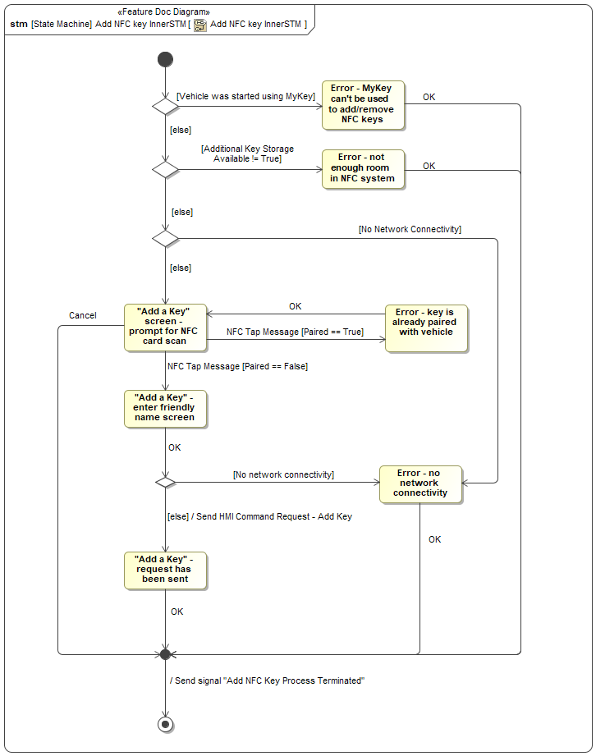

Figure 2: Add NFC key InnerSTM

### Add NFC key InnerSTM states

|  |  |
| --- | --- |
| **State** | **Requirements Reference** (optional) |
| "Add a Key" - enter friendly name screen | * ID=REQ-NFC-ES-204 : Prompt Screen: Naming a New NFC Card |
| "Add a Key" - request has been sent | * ID=REQ-NFC-ES-205 : Progress Screen: Sending Key Add Request * ID=REQ-NFC-ES-218 : Success Screen: Key Add Request Sent |
| "Add a Key" screen - prompt for NFC card scan | * ID=REQ-NFC-ES-206 : Prompt Screen: Selecting "Add a Key" Button |
| Error - key is already paired with vehicle | * ID=REQ-NFC-ES-174 : Error Screen: Scanning an Existing NFC Card |
| Error - MyKey can't be used to add/remove NFC keys | * ID=REQ-NFC-ES-175 : Error Screen: Selecting "Add a Key" Button When MyKey is Active * ID=REQ-NFC-ES-234 : Error Screen: Selecting "Delete Key" Button When MyKey is Active |
| Error - no network connectivity | * ID=REQ-NFC-ES-178 : Error Screen: Selecting "Add a Key" Button When There Is No Network Connectivity * ID=REQ-NFC-ES-177 : Error Screen: Terminating Key Add Request When There Is No Network Connectivity * ID=REQ-NFC-ES-168 : Display System: Error screen after user confirms NFC Key Card Delete request |
| Error - not enough room in NFC system | * ID=REQ-NFC-ES-176 : Error Screen: Selecting "Add a Key" Button When Key Storage is Full |
| "Add a Key" - request has been sent | * ID=REQ-NFC-ES-205 : Progress Screen: Sending Key Add Request * ID=REQ-NFC-ES-218 : Success Screen: Key Add Request Sent |
| "Add a Key" screen - prompt for NFC card scan | * ID=REQ-NFC-ES-206 : Prompt Screen: Selecting "Add a Key" Button |
| Error - key is already paired with vehicle | * ID=REQ-NFC-ES-174 : Error Screen: Scanning an Existing NFC Card |
| Error - MyKey can't be used to add/remove NFC keys | * ID=REQ-NFC-ES-175 : Error Screen: Selecting "Add a Key" Button When MyKey is Active * ID=REQ-NFC-ES-234 : Error Screen: Selecting "Delete Key" Button When MyKey is Active |
| Error - no network connectivity | * ID=REQ-NFC-ES-178 : Error Screen: Selecting "Add a Key" Button When There Is No Network Connectivity * ID=REQ-NFC-ES-177 : Error Screen: Terminating Key Add Request When There Is No Network Connectivity * ID=REQ-NFC-ES-168 : Display System: Error screen after user confirms NFC Key Card Delete request |
| Error - not enough room in NFC system | * ID=REQ-NFC-ES-176 : Error Screen: Selecting "Add a Key" Button When Key Storage is Full |

Table 2: Operation Modes and States on Add NFC key InnerSTM

### Add NFC key InnerSTM requirements

REQ-NFC-ES-168 Display System: Error screen after user confirms NFC Key Card Delete request

If after the user confirms their deletion request, the vehicle loses network connectivity , the NFC Display System shall terminate the NFC Key Card Delete flow and display an NFC Feature related center-stack pop-up which includes:

- Reason text: "NFC Key Card Delete Request Cancelled - No connectivity"

- The FESN or Friendly name of the selected NFC Key Card

**Rationale**: Informs user that request to delete key has failed due to lack of network connectivity or because of a system timeout

REQ-NFC-ES-174 Error Screen: Scanning an Existing NFC Card

If after the Display System has initated the "Add NFC Key" flow, it receives an an "NFC Tap Message" with "Paired" status signal == True, it shall terminate the "Add NFC Key" flow and display an NFC Feature related center-stack pop-up which includes:

- Reason text: "Error - Key is already paired with vehicle"

- The FESN or Friendly name of the selected NFC Key Card

**Rationale**: This screen informs the user that the scanned NFC card is already paired to the vehicle.

REQ-NFC-ES-175 Error Screen: Selecting "Add a Key" Button When MyKey is Active

When a user presses the greyed out "Add NFC Device" Soft button while the following conditions are true:

- Current MyKey Level == MyKey

The Display system shall display an NFC Feature related center-stack pop-up which includes:

- Reason text: "Error - MyKey can't be used to add/delete NFC Keys"

**Rationale**: This screen informs the user that NFC cards cannot be added to the vehicle when MyKey is active.

REQ-NFC-ES-176 Error Screen: Selecting "Add a Key" Button When Key Storage is Full

When a user presses the greyed out "Add NFC Device" Soft button on the "Unified Key Management" screen while the following conditions are true:

- "Additional Key Storage Available" status from NFC System != Available

The Display system shall display an NFC Feature related center-stack pop-up which includes:

- Reason text: "Error - Not enough room in NFC System"

**Rationale**: This screen informs the user that key storage is full when they attempt to add an NFC card.

REQ-NFC-ES-177 Error Screen: Terminating Key Add Request When There Is No Network Connectivity

If after the Display System has initated the "Add NFC Key" flow and entered in a "Friendly Name" the vehicle loses connectivity it shall terminate the "Add NFC Key" flow and display an NFC Feature related center-stack pop-up which includes:

- Reason text: "Error - No Network Connectivity"

**Rationale**: This screen informs the user that the request cannot be completed because there is no network connectivity.

REQ-NFC-ES-178 Error Screen: Selecting "Add a Key" Button When There Is No Network Connectivity

If after the Display System has initated the "Add NFC Key" flow, the vehicle loses connectivity it shall terminate the "Add NFC Key" flow and display an NFC Feature related center-stack pop-up which includes:

- Reason text: "Error - No Network Connectivity"

**Rationale**: This screen informs the user that the action of adding an NFC card requires network connectivity.

REQ-NFC-ES-204 Prompt Screen: Naming a New NFC Card

If the Display System receives an "NFC Tap Message" with "Paired" Signal == "False", during the "Add a Key" flow then the Display System shall display the "Add a Key" - enter friendly name screen" screen.

**Rationale**: This screen prompts the user to name the new NFC card during the key add flow.

REQ-NFC-ES-205 Progress Screen: Sending Key Add Request

When the user enters the name of the NFC card and the vehicle has network connectivity, the Display System shall display the "Sending Request screen" screen.

**Rationale**: This screen informs the user of the progress of the key add request.

REQ-NFC-ES-206 Prompt Screen: Selecting "Add a Key" Button

When the user presses the "Add a Key" button on the "Unified Key Management" screen, and all of the following conditions apply

- the key that started the vehicle was not a MyKey

- the "Additional Key Storage Available" status signal from the NFC System is True

- the vehicle has network connectivity

the Display System shall display the "Add a Key" screen - prompt for NFC card" screen.

**Rationale**: This screen prompts the user to scan a new NFC card during the key add flow.

REQ-NFC-ES-218 Success Screen: Key Add Request Sent

When the Display System receives an "NFC Command Complete Message" with "Successful" signal == "True", during the "Add a Key" flow the Display System shall display the "Add a Key" - request has been sent" screen.

**Rationale**: This screen informs the user that the key add request has been sent.

REQ-NFC-ES-234 Error Screen: Selecting "Delete Key" Button When MyKey is Active

When a user presses the greyed out "Delete NFC Key" Soft button while the following conditions are true:

- Current MyKey Level == MyKey

The Display system shall display a momentary pop-up to indicate the NFC Delete operation isnt allowed while a MyKey device is in use

**Rationale**: This screen informs the user that NFC cards cannot be deleted from the vehicle when MyKey is active.

## MyKey Management Inner STM

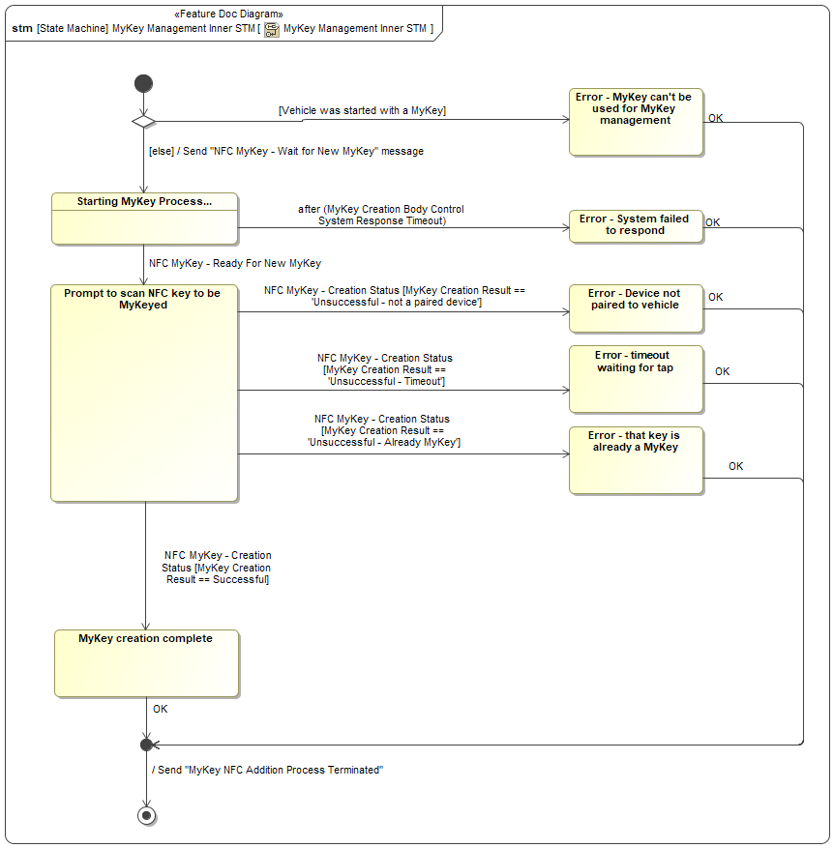

Figure 3: MyKey Management Inner STM

### MyKey Management Inner STM states

|  |  |
| --- | --- |
| **State** | **Requirements Reference** (optional) |
| Error - Device not paired to vehicle | * ID=REQ-NFC-ES-195 : NFC MyKey Creation Device not paired error |
| Error - MyKey can't be used for MyKey management | * ID=REQ-NFC-ES-244 : NFC MyKey Creation not allowed while MyKey in use |
| Error - System failed to respond | * ID=REQ-NFC-ES-193 : NFC MyKey Creation System Error timeout |
| Error - that key is already a MyKey | * ID=REQ-NFC-ES-194 : NFC MyKey Creation Already a MyKey error |
| Error - timeout waiting for tap | * ID=REQ-NFC-ES-196 : NFC MyKey Creation waiting for Tap timeout |
| MyKey creation complete | * ID=REQ-NFC-ES-192 : NFC MyKey Creation Flow Success |
| Prompt to scan NFC key to be MyKeyed |  |
| Starting MyKey Process... | * ID=REQ-NFC-ES-180 : Initiate NFC MyKey Creation Flow |

Table 3: Operation Modes and States on MyKey Management Inner STM

### MyKey Management Inner STM requirements

REQ-NFC-ES-180 Initiate NFC MyKey Creation Flow

When the user presses the “Create an NFC MyKey” soft button, the Display System shall initiate the “Create an NFC MyKey” flow by:

- Transmitting an "NFC MyKey – Wait for New MyKey" Request Signal

**Rationale**: Pressing the "Create an NFC MyKey" Softbutton should initiate the creation flow

REQ-NFC-ES-192 NFC MyKey Creation Flow Success

When the The Display System receives "NFC MyKey Creation Result" Status signal == “Successful” it shall display an NFC Feature related center-stack pop-up which includes:

- Reason text: "MyKey Creation Flow Successful"

**Rationale**: Notify the user after an NFC Device was successfully updated to be a MyKey

REQ-NFC-ES-193 NFC MyKey Creation System Error timeout

If after Starting the MyKey Creation process the Display System does not receive a "NFC MyKey - Ready for New MyKey" signal within "Display MyKey Creation Time" configuration parameter timer of the Display System, it shall exit the “Create an NFC MyKey” flow and

display an NFC Feature related center-stack pop-up which includes:

- Reason text: "Error - System Failed to Respond"

**Rationale**: MyKey Creation exit path for if there is a system error after initiating the create flow

REQ-NFC-ES-194 NFC MyKey Creation Already a MyKey error

If after Starting the MyKey Creation process and having received "NFC MyKey - Ready for New MyKey" signal == "True", the Display System receives an "NFC MyKey - Creation Status" Message with "Mykey Creation Result" signal == "Unsuccessful - already a MyKey" it shall exit the “Create an NFC MyKey” flow and display an NFC Feature related center-stack pop-up which includes:

- Reason text: "Error - Already a MyKey"

**Rationale**: MyKey Creation should exit if the user scans an existing NFC MyKey during the creation flow

REQ-NFC-ES-195 NFC MyKey Creation Device not paired error

If after Starting the MyKey Creation process and having received "NFC MyKey - Ready for New MyKey" signal == "True", the Display System receives an "NFC MyKey - Creation Status" Message with "Mykey Creation Result" signal == "Unsuccessful - Not a paired device" it shall exit the “Create an NFC MyKey” flow and display an NFC Feature related center-stack pop-up which includes:

- Reason text: "Error - Device not paired to vehicle"

**Rationale**: MyKey Creation should exit if the user scans a device that wasn't previously paired to the vehicle

REQ-NFC-ES-196 NFC MyKey Creation waiting for Tap timeout

If after Starting the MyKey Creation process and having received "NFC MyKey - Ready for New MyKey" signal == "True", the Display System receives an "NFC MyKey - Creation Status" Message with "Mykey Creation Result" signal == "Unsuccessful – Timeout" it shall exit the “Create an NFC MyKey” flow and display an NFC Feature related center-stack pop-up which includes:

- Reason text: "Error - Timeout waiting for tap"

**Rationale**: MyKey Creation should exit if the user does not take an action within a specified timeframe after initiating the create flow

REQ-NFC-ES-244 NFC MyKey Creation not allowed while MyKey in use

When a user presses the greyed out "Create NFC MyKey" Soft button while the following conditions are true:

- Current MyKey Level == MyKey

The Display System shall not initiate the “Create an NFC MyKey” flow and momentarily indicate that the Create NFC MyKey operation isn't allowed while a MyKey device is in use

*HMI to determine exact verbiage of momentary pop-up

**Rationale**: MyKey user is not allowed to create additional MyKey devices

## Personal Profiles Linking STM

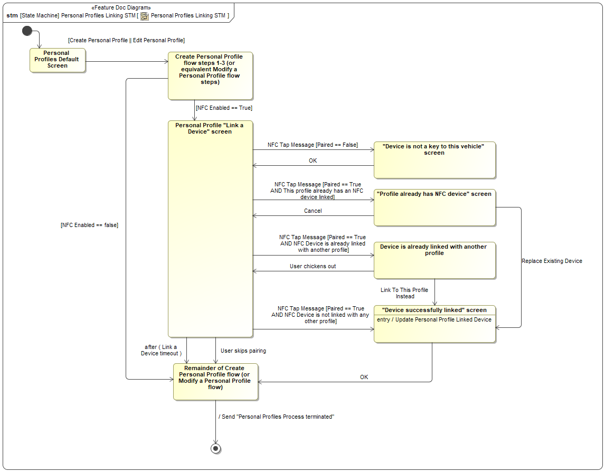

Figure 4: Personal Profiles Linking STM

### Personal Profiles Linking STM states

|  |  |
| --- | --- |
| **State** | **Requirements Reference** (optional) |
| "Device is not a key to this vehicle" screen | * ID=REQ-NFC-ES-181 : invalid NFC device used * ID=REQ-NFC-ES-182 : Transmit Driver Information Message = "Prompt for NFC Scan" on transition |
| "Device successfully linked" screen | * ID=REQ-NFC-ES-190 : NFC device already linked to another Personal Profile -ON LINK current NFC to current Personal Profile option * ID=REQ-NFC-ES-220 : Successful NFC Device link to current Personal Profile |
| "Profile already has NFC device" screen | * ID=REQ-NFC-ES-202 : Personal Profile already has NFC device Paired ON LINK current NFC to current Personal Profile option * ID=REQ-NFC-ES-203 : Personal Profile already has NFC device Paired ON LINK current NFC to different Personal Profile option * ID=REQ-NFC-ES-200 : NFC Feature enabled on Display system * ID=REQ-NFC-ES-199 : Personal Profile already has NFC device Paired |
| Create Personal Profile flow steps 1-3 (or equivalent Modify a Personal Profile flow steps) |  |
| Device is already linked with another profile | * ID=REQ-NFC-ES-187 : NFC device already linked to another Personal Profile * ID=REQ-NFC-ES-191 : NFC device already linked to another Personal Profile -ON LINK current NFC to different Personal Profile option |
| Personal Profile "Link a Device" screen | * ID=REQ-NFC-ES-151 : abort Personal Profile NFC Pairing button * ID=REQ-NFC-ES-179 : Feature availability for Personal Profile linking * ID=REQ-NFC-ES-198 : Personal Profile NFC Pairing instructions |
| Personal Profiles Default Screen |  |
| Remainder of Create Personal Profile flow (or Modify a Personal Profile flow) |  |

Table 4: Operation Modes and States on Personal Profiles Linking STM

### Personal Profiles Linking STM requirements

REQ-NFC-ES-151 abort Personal Profile NFC Pairing button

The "Personal Profile "Link a Device" screen shall include a cancel/exit/skip button that allows the USER to abort the NFC Personal Profile Pairing process.

**Rationale**: allow a user to exit the NFC process without setting up a Personal Profile for an NFC device

REQ-NFC-ES-179 Feature availability for Personal Profile linking

When "NFC Enabled on System" configuration parameter of the Display System == True, the Display System shall include the option to link an NFC device within the Personal Profile Pairing process.

**Rationale**: ensure NFC features are available on the vehicle before allowing a NFC device to be setup as a Personal Profile

REQ-NFC-ES-181 invalid NFC device used

If after the user has initiated the "Link a device" flow within the Personal Profiles menu, the display system receives an "NFC Tap" message with "Paired" status == False, the Display system shall skip the Profile to NFC Device pairing process and display an NFC Feature related center-stack pop-up which includes:

- Reason text: "Device is not a key to this vehicle"

**Rationale**: informs user that an invalid NFC device was used to link to a Personal Profile

REQ-NFC-ES-182 Transmit Driver Information Message = "Prompt for NFC Scan" on transition

When the Body Control System's "Transmit body control system related indication" state machine enters the "Prompt for NFC Scan" state, the Body Control System shall immediately:

Transmit Driver Information Message = "Prompt for NFC Scan"

REQ-NFC-ES-187 NFC device already linked to another Personal Profile

If after the user has initiated the "Link a device" flow within the Personal Profiles menu, the display system receives an "NFC Tap" message with "Paired" status == True, and "FESN" value that is already paired to a profile the Display system shall display an NFC Feature related center-stack pop-up which includes:

- Reason text: "Device is paired to another profile"

- Option to overwrite previous pairing

- Option to skip pairing

**Rationale**: inform USER that another Personal Profile already has the current NFC device linked to it.

REQ-NFC-ES-190 NFC device already linked to another Personal Profile -ON LINK current NFC to current Personal Profile option

When if the user selects to "overwrite previous pairing" while in the "Link a device" flow within the Personal Profiles Menu, the Display System shall associte the selected profile with the "NFC Tap" message "FESN" value and display an NFC Feature related center-stack pop-up which includes:

- Reason text: "Device successfully paired to profile"

**Rationale**: Allow USER to link current NFC device to current profile.

REQ-NFC-ES-191 NFC device already linked to another Personal Profile -ON LINK current NFC to different Personal Profile option

When the option "Link a different NFC device to current Personal Profile" is selected in the "Device is already linked with another profile" screen, the Display System shall transition back to "Personal Profile "Link a Device" screen.

Note: the "Personal Profile "Link a Device" screen wording or instructions may differ slightly from original screen, prioritizing requirements detailed in REQ. NFC Personal Profile Pairing process consistency

**Rationale**: Allow USER to link a different NFC device to current profile.

REQ-NFC-ES-198 Personal Profile NFC Pairing instructions

The "Personal Profile "Link a Device" screen shall include instructions to pair an NFC device. The instructions shall include at minimum:

- Tap NFC device in interior reader

note: exact wording shall be reviewed by and concurred with HMI.

**Rationale**: provide instructions on how to pair an NFC device to the users personal profiles

REQ-NFC-ES-199 Personal Profile already has NFC device Paired

If the user has initiated the "Link a device" flow within the Personal Profiles menu for a Profile that already has an NFC Device associated to it, the Display system shall display an NFC Feature related center-stack pop-up which includes:

- Reason text: "Profile already associated to NFC Device"

- Option to overwrite previous pairing

- Option to skip pairing

**Rationale**: inform USER that this Personal Profile already has a NFC device linked to it.

REQ-NFC-ES-200 NFC Feature enabled on Display system

The Display System shall support all of the NFC Feature specific functionality while the "NFC Enabled" configuration parameter of the Display System is set to "Enabled"

REQ-NFC-ES-202 Personal Profile already has NFC device Paired ON LINK current NFC to current Personal Profile option

When the option "Link current NFC Device to current Personal Profile" is selected in the "Profile already has NFC device" screen, the Display System shall sequentially complete the following:

- Remove linkage of the current Personal Profile NFC device value property ESN

- Link the NFC tap message value property ESN to the current selected Personal Profile.

- transition to "Device successfully linked" screen.

**Rationale**: Allow USER to link current NFC device to current profile.

REQ-NFC-ES-203 Personal Profile already has NFC device Paired ON LINK current NFC to different Personal Profile option

When the option "Link NFC Device to different Personal Profile" is selected in the "Profile already has NFC device" screen, the Display System shall transition back to "Personal Profile "Link a Device" screen.

Note: the "Personal Profile "Link a Device" screen wording or instructions may differ slightly from original screen, prioritizing requirements detailed in REQ. NFC Personal Profile Pairing process consistency

**Rationale**: Allow USER to link a different NFC device to current profile.

REQ-NFC-ES-220 Successful NFC Device link to current Personal Profile

When the CONDITIONS below are met, the Display System shall display the "Device successfully linked " screen after completing the following sequential ACTIONS:

CONDITIONS:

- current screen == "Personal Profile "Link a Device" , AND

- NFC tap message signal "Paired" == True, AND

- NFC Tap Message "FESN" signal value not currently paired to any other Personal Profile AND

- Selected Personal Profile not already associated to an NFC device

ACTIONS:

- Link the current NFC tap message value property ESN to the current selected Personal Profile.

**Rationale**: Allow USER to link current NFC device to current profile.

## Remove NFC Key Inner STM

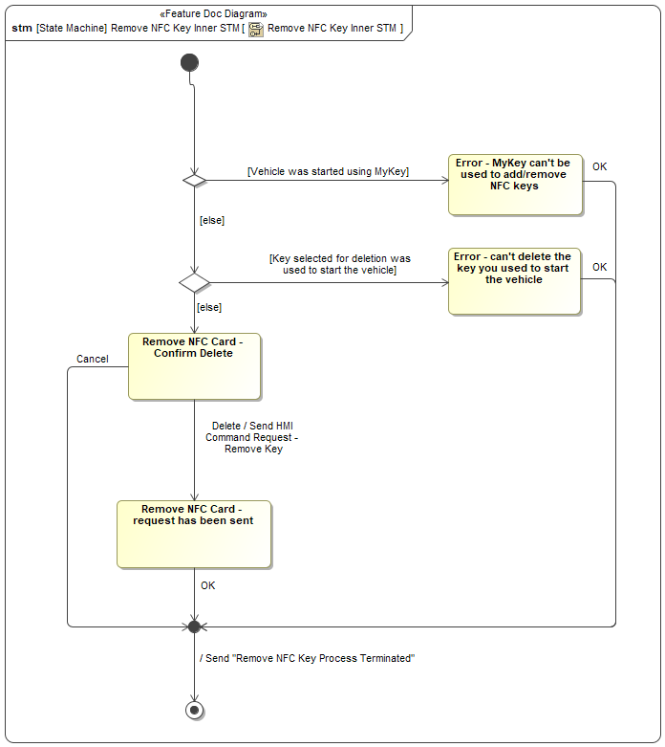

Figure 5: Remove NFC Key Inner STM

### Remove NFC Key Inner STM states

|  |  |
| --- | --- |
| **State** | **Requirements Reference** (optional) |
| Error - can't delete the key you used to start the vehicle | * ID=REQ-NFC-ES-243 : Error Screen: Selecting "Delete Key" Button for key used to start the vehicle |
| Error - MyKey can't be used to add/remove NFC keys |  |
| Remove NFC Card - Confirm Delete | * ID=REQ-NFC-ES-166 : Display System: Confirmation Screen when NFC Key Deletion is requested |
| Remove NFC Card - request has been sent | * ID=REQ-NFC-ES-170 : Display System: Success screen after user confirms NFC Key Card Delete request * ID=REQ-NFC-ES-228 : Remove NFC Card - send HMI Command Request |

Table 5: Operation Modes and States on Remove NFC Key Inner STM

### Remove NFC Key Inner STM requirements

REQ-NFC-ES-166 Display System: Confirmation Screen when NFC Key Deletion is requested

After the "Delete Key" button is pressed, and the conditions to allow deletion are true (per REQ-NFC-ES-165) the NFC Display System shall display an NFC Feature related center-stack pop-up asking the user to confirm deletion.

**Rationale**: Requires user to confirm they really wanted to delete an NFC Key Card

REQ-NFC-ES-170 Display System: Success screen after user confirms NFC Key Card Delete request

The NFC display System shall provide a screen to inform user that "request to Remove NFC Card" has been sent after the "Confirm Delete Screen" button is pressed and all conditions are satisfied:

- Display "Requesting Command" == Remove NFC Key Card succeeded if "Vehicle Network status" == True (connected) & if a system timeout == False

**Rationale**: Informs user that request to delete key has been sent successfully

REQ-NFC-ES-228 Remove NFC Card - send HMI Command Request

When the Center Stack Display System transitions to displaying the "Remove NFC Card - request has been sent" screen during the flow to unpair an existing NFC key card, the Center Stack Display System shall immediately transmit an "HMI Command Request" message with the following properties:

- Friendly Name: Null or empty string

- FESN: The FESN associated with the NFC key card that the user selected for unpairing in the in-vehicle HMI

- Command Type: Delete Key

**Rationale**: This message triggers the NFC System to send a command request to the cloud backend.

REQ-NFC-ES-243 Error Screen: Selecting "Delete Key" Button for key used to start the vehicle

When a user presses the greyed out "Delete NFC Key" Soft button while the following conditions are true:

- Display System value property "NFC Enabled" == True

- Selected key == "Starting authorized key" value property of the "NFC Control System"

The Display system shall display an NFC Feature related center-stack pop-up which includes:

- Reason text: "Error - Device is in use"

**Rationale**: This screen informs the user that NFC cards cannot be deleted from the vehicle when MyKey is active.

# Revision History

|  |  |  |  |
| --- | --- | --- | --- |
| Revision | Date | Description | Responsible |
| 2020-05-22 | 5/22/2020 | Initial Functional Specification release for P708 UPV0 | abonnel1, fehsan2, ekarpins |
| 2020-08-24 | 8/24/2020 | Updated release for P708 UPV1 | abonnel1, fehsan2,  ekarpins |
|  |  |  |  |

## Template Revisions

*#Important: Do not change this section*

|  |  |  |  |  |
| --- | --- | --- | --- | --- |
| Version | Rev. | Date | Description | Responsible |
| *1* | *0* | *2016-02-26* | *Initial version, derived from FDS* | *Jbaden1* |
| *1* | *1* | *2016-02-26* | *Word properties corrected* | *Jbaden1* |
| *1* | *2* | *2016-03-10* | *Clean up of document meta data (Word properties)* | *Jbaden1* |
| *1* | *3* | *2016-03-22* | * *Footer formatting corrected (Issue 19)* * *“Constraints” chapter renamed to “Input Requirements” (Issue 20)* | *Jbaden1* |
| *1* | *4* | *2016-04-20* | * *Broken Wiki links repaired* | *Jbaden1* |
| *2* | *0* | *2016-06-10* | * *Document metadata adapted. Prepared for new macros* * *DTC table removed* * *HMI function added as a chapter (details still to be refined)* * *Signal / Parameter IDs column deleted interface tables* | *Jbaden1* |
| *2* | *1* | *2016-07-14* | * *Converted to SysML diagrams* * *HMI section further elaborated* * *Template version added to footer* * *Dedicated Startup / Shutdown sections removed (only hints added)* * *Data Dictionary reworked and Signal / Parameter IDs column re-introduced* | *Jbaden1* |
| *2* | *2* | *2016-12-07* | * *Minor formatting changes* | *Jbaden1* |
| *3* |  |  | *Skipped to synchronize with Specification_Macros.dotm* |  |
| *4* |  |
| *5* | *0* | *2017-01-13* | * *Meta data updated for specification macros, version 3.1* * *SW Unit chapter removed for the time being* * *Green boxes added for user hints* | *Jbaden1* |
| *5* | *1* | *2017-01-18* | * *Some additional hints.* * *Hyperlinks highlighted in hints* | *Jbaden1* |
| *6* | *0* | *2017-04-28* | * *Editorial change. Hints added to chapter 4.1.4* * *Chapter “Traceability Matrix” removed* | *Jbaden1* |
| *6* | *0* | *2018-04-28* | * *CR69/63: New chapters added for Functional Safety (FTTI and Technical Safety Requirements)* * *CR53: New coversheet + additional meta-data* * *CR76: merge sections for configuration and for calibration parameters into one on Function Level* | *Jbaden1* |
| *6* | *0* | *2018-08-06* | * *CR66: Fix version numbering in footer of Function Spec* | *Jbaden1* |
| *6* | *0* | *2018-09-28* | * *Broken links to RE Wiki repaired* | *Jbaden1* |
| *6* | *0* | *2018-10-31* | * *Minor corrections on cover sheet and in footer to be more GIS compliant and VSEM aligned* * *“Overview” and “Description” exchanged in headings (following common sense)* | *Jbaden1* |
| *6* | *0* | *2018-11-12* | * *Explanatory text in Variants” section revised* * *Functional Safety modifications as agreed with FuSa core team (Baseline: November 2018 Dearborn On-Site)* | *Jbaden1* |
| *M* |  | *2019-04-02* | * *Initial version of SysML report template* | *snuesch* |
| *M* |  | *2019-04-05* | * *Improved dialog boxes to select function group* | *snuesch* |

# Appendix

## Data Dictionary

### Logical Messages

#### NFC MyKey - Wait for New MyKey

This signal is sent from the HMI system to the Body Control System when the user requests MyKey creation. The signal indicates that the Body Control System should make the next NFC device scanned a MyKey.

*(This message does not contain any signals.)*

#### NFC Command

This message is transmitted from the Cloud Backend System to the NFC System to cause a command to be executed on the NFC System.

##### NFC Command – owned signals

|  |  |  |
| --- | --- | --- |
| **Signal** | **Description** | **Type (encoding)** |
| Command type | The specific command that is being issued to the NFC System. Always required. | NFC Command Type |
| Command data | The specific data required to complete the requested add/delete/enable/disable command | Command Data |
| Command origin | Whether the command originated from the vehicle, the fleet management system or a service tool | Command Origin |
| Command data | The specific data required to complete the requested add/delete/enable/disable command | Command Data |
| Command origin | Whether the command originated from the vehicle, the fleet management system or a service tool | Command Origin |
|  |  |  |

#### Device Entered Field

To indicate that a device has entered within the detection range of an NFC Reader Antenna

##### Device Entered Field – owned signals

|  |  |  |
| --- | --- | --- |
| **Signal** | **Description** | **Type (encoding)** |
| Location | Whether a device was detected at an interior or exterior reader antenna's field | NFC Location |
|

#### Device Exited Field

To indicate that a device has exited the detection range of an NFC Reader after being detected.

##### Device Exited Field – owned signals

|  |  |  |
| --- | --- | --- |
| **Signal** | **Description** | **Type (encoding)** |
| Location | Whether a device has exited the detection range of an interior or exterior reader antenna's field | NFC Location |
|

#### Make a new MyKey

*(This message does not contain any signals.)*

#### NFC Device Detected

Updated and sent when an NFC Device is detected at a Reader

##### NFC Device Detected – owned signals

|  |  |  |
| --- | --- | --- |
| **Signal** | **Description** | **Type (encoding)** |
| Location | Whether an NFC Device was detected at an interior or exterior reader | NFC Location |
|

#### Master Reset Command

The signal that is emitted when a Master Reset event is triggered, whether it was triggered through the in-vehicle HMI or remotely (for fleets). This signal is used by the NFC System to trigger the NFC System's Master Reset behavior.

*(This message does not contain any signals.)*

#### Enable/Disable NFC Feature

This signal is a command to devices in the vehicle to either enable or disable that device's behavior related to the NFC Entry and Starting feature.

The device should enable or disable the feature behavior based on the value of the "Enable/Disable" property.

##### Enable/Disable NFC Feature – owned signals

|  |  |  |
| --- | --- | --- |
| **Signal** | **Description** | **Type (encoding)** |
| Enable/Disable | Whether the feature should be enabled or disabled on the target module | Enable/Disable |
|

#### NFC MyKey - Creation Status

Transmitted from the Body Control System to the Display System to provide feedback on the state of the Body Control System during a MyKey creation operation.

##### NFC MyKey - Creation Status – owned signals

|  |  |  |
| --- | --- | --- |
| **Signal** | **Description** | **Type (encoding)** |
| NFC MyKey Creation Status | A signal from the Body Control System indicating the status of a MyKey creation operation. | NFC MyKey Creation Result |
|

#### Trigger Reauthorization

Message is updated and sent to reauthorize a device on system wake-up, if it had been left on the reader prior to wake-up

##### Trigger Reauthorization – owned signals

|  |  |  |
| --- | --- | --- |
| **Signal** | **Description** | **Type (encoding)** |
| Location | Whether the device was detected at an Interior or Exterior reader | NFC Location |
|

#### NFC Local Event

This is emitted by the NFC system whenever a valid command is received by the system, after the NFC System finishes executing the command. A valid command is one that is syntactically correct and has a valid signature from Ford.

For example, this signal is emitted during the process for creating a new NFC key card pairing, when the actual pairing command is received and executed by the NFC system.

Multiple systems on the vehicle consume this message to trigger behaviors when key changes occur: for example, when a key is added to the vehicle, the HMI system uses this signal to trigger a confirmation pop-up, and the Body Control System uses this signal as a trigger to clear the associated MyKey table entry.

##### NFC Local Event – owned signals

|  |  |  |
| --- | --- | --- |
| **Signal** | **Description** | **Type (encoding)** |
| Command Type | The type of command that was completed (or not completed). | NFC Command Type |
| Successful | Whether the command in question was executed successfully by the NFC system. | Boolean |
| Key Index | If the command relates to a specific key in the NFC system, this property indicates the NFC key index of that key. | Integer |
| FESN | If the command relates to a specific NFC key card, the FESN of that key card. Undefined otherwise. | FESN |
| HMI visible | Whether a notification should be displayed for this event in the in-vehicle HMI. | Boolean |
|

#### Manufacturing Pairing Alert

The Manufacturing Pairing Alert is sent just after the Provisioning Alert, after the vehicle has been configured at end-of-line. It contains information about the cards that were paired with the vehicle on the assembly line.

##### Manufacturing Pairing Alert – owned signals

|  |  |  |
| --- | --- | --- |
| **Signal** | **Description** | **Type (encoding)** |
| VIN | The VIN of the vehicle that is sending the alert. | VIN |
| Card Data | The NFC Device's credential, FESN, and other pairing related data that was generated at the time of pairing | Manufacturing Pairing Alert Data |
|

#### Retail User Approval Result

This message is sent from the Cloud Backend System to the vehicle to notify the vehicle of the result of a previously requested NFC command. The message is only transmitted if the request has failed, timed out, or been denied -- if the request is approved, the vehicle is notified with an NFC Command Message.

##### Retail User Approval Result – owned signals

|  |  |  |
| --- | --- | --- |
| **Signal** | **Description** | **Type (encoding)** |
| Request Status | The state of the specified approval request. | Retail Owner Approval Status |
| Payload ID | The payload ID associated with the specific device that is being either added to or deleted from the vehicle | Payload ID |
|

#### NFC Tap Message

This message is emitted by the NFC system every time a transaction is completed with any compatible NFC device (Ford NFC key card or CCC-compliant smart device). This includes non-authorized devices - scanning a device that is not paired with the vehicle will still generate an NFC Tap.

This message is consumed by multiple systems in the vehicle to trigger behaviors when an NFC device is tapped. For example, the Body Control System uses this message to trigger vehicle locking/unlocking on an exterior device tap.

##### NFC Tap Message – owned signals

|  |  |  |
| --- | --- | --- |
| **Signal** | **Description** | **Type (encoding)** |
| Paired | Whether the device that was scanned is authorized to this vehicle (i.e., it is paired). True if the device was authorized. | Boolean |
| Tap Duration | Whether the user performed a short tap or a long tap. A short tap occurs whenever an NFC device was held at the reader for any duration long enough to perform a transaction. A separate NFC Tap message is emitted with Tap Duration = Long Tap if the user continues to hold the device at the reader for longer than the long tap threshold (a second or two). | NFC Tap Duration |
| Location | The location of the NFC reader where the tap event occurred. | NFC Location |
| Key Index | The internal index of the NFC key that was tapped, if that key was authorized to the vehicle. If the key was not authorized, this value is undefined. | Integer |
| Card FESN | The FESN (human-readable serial number) of the NFC key card that was scanned, if the device that was scanned was an NFC key card. | FESN |
|

#### Retail User Approval Request

The message that is transmitted from the Cloud Backend System to the Mobile App to prompt the retail owner to approve or deny a request that was created using the in-vehicle HMI.

##### Retail User Approval Request – owned signals

|  |  |  |
| --- | --- | --- |
| **Signal** | **Description** | **Type (encoding)** |
| VIN | The Vehicle Identification Number of the vehicle the selected command is being requested for | VIN |
| Card FESN | The Ford Electronic Serial Number for the NFC Card/Device either being added or deleted. | FESN |
| Request Type | The specific type of action being requested: Adding a Key, Deleting a Key | NFC Command Type |
| Key Friendly Name | The user friendly name of the NFC Card/Device either being added or deleted. | String |
| Payload ID | Unique pairing ID that is created and maintained on the cloud side to keep track of vehicle to NFC Device pairings. | Payload ID |
|

#### NFC Command Request - Retail

The message that is sent from a vehicle to the NFC Cloud Backend when a retail user requests an NFC command using the in-vehicle HMI.

##### NFC Command Request - Retail – owned signals

|  |  |  |
| --- | --- | --- |
| **Signal** | **Description** | **Type (encoding)** |
| Local ID | Vehicle to NFC Device pairing ID that is generated by the vehicle at the time of a Retail NFC Device Add request. It is maintained until either the request is completed, rejected, or timed out. | Local ID |
| VIN | The vehicle identification number of the target vehicle | VIN |
| FESN | The Ford Electronic Serial Number for the NFC Card/Device either being added or deleted. | FESN |
| Command type | The add, delete, enable or disable command being requested | NFC Command Type |
| Friendly Name | The user selected name for their NFC Device | String |
|

#### Modem Deauthorization

We expect this signal to be sent when the vehicle's modem becomes deauthorized for any reason.

*(This message does not contain any signals.)*

#### Driver information message

Message sent from the Body Control System to the Driver Information System that is used for giving NFC Scanning and Starting specific instruction

##### Driver information message – owned signals

|  |  |  |
| --- | --- | --- |
| **Signal** | **Description** | **Type (encoding)** |
| Indication | Indication to inform the driver whether they need to scan their NFC Device, press the start button or if they're okay to drive. Set to Null for all other conditions | Driver info indication |
|

#### New Fleet Card Alert

This message is sent from the NFC Cloud Backend to the FCS Cloud Backend when a Provisioning Alert message is received from a vehicle. The purpose of the message is to enable the FCS Cloud Backend to create an association between an NFC card and a particular fleet, without implying that that card is paired with any particular vehicle in that fleet.

##### New Fleet Card Alert – owned signals

|  |  |  |
| --- | --- | --- |
| **Signal** | **Description** | **Type (encoding)** |
| Associated Vehicle | The vehicle that the NFC card in question was shipped with. Because this alert is used to create associations between fleets and cards, NOT between vehicles and cards, this vehicle probably does NOT have a pairing with the NFC card in question, but the NFC card is physically shipped with the vehicle as its unpaired card. | VIN |
| NFC Card | The NFC card that should be associated with the fleet that the "Associated Vehicle" is enrolled in. Note that this NFC card is not paired with the "Associated Vehicle" - the card is being delivered as an unpaired card, but is physically shipped with the "Associated Vehicle". | FESN |
|

#### Mobile App Approval Response

The message sent by the Mobile App that contains the user's decision on a specific approval request.

##### Mobile App Approval Response – owned signals

|  |  |  |
| --- | --- | --- |
| **Signal** | **Description** | **Type (encoding)** |
| Approval Response | The approval response a Retail admin - user authorized to the vehicle's modem - can provide in response to receiving requests for adding or deleting NFC devices from their vehicle | Retail Owner Approval Status |
| Payload ID | The payload ID associated with the specific device that is being either added to or deleted from the vehicle | Payload ID |
|

#### NFC Command Request - Service

The message that is sent from the service tool to the NFC Cloud Backend when a technician requests a command be issued to a vehicle's NFC System.

##### NFC Command Request - Service – owned signals

|  |  |  |
| --- | --- | --- |
| **Signal** | **Description** | **Type (encoding)** |
| Key Type | To identify whether the NFC Key/Device being selected for Add or Delete is a Factory Key, a Retail Key, or Fleet User Key. N/A for Enable or Disable requests | NFC Key Type |
| FESN | The Ford Electronic Serial Number for the NFC Card/Device either being added or deleted. N/A for Enable or Disable requests | FESN |
| Friendly Name | The User friendly name of the NFC Card/Device either being added or deleted. N/A for Enable or Disable requests | String |
| Command type | The specific type of action being requested: Adding a Key, Deleting a Key, Disabling NFC feature on target module, Enabling NFC Feature on target module | NFC Command Type |
| VIN | The Vehicle Identification Number of the vehicle the selected command is being requested for | VIN |
| Credentials | The Credential information tied to the specific service technician making the requests. |  |
|

#### NFC MyKey - Cancel MyKey Creation

This signal indicates that the user has canceled the MyKey creation process, and the Body Control System should no longer make the next scanned key a MyKey.

*(This message does not contain any signals.)*

#### NFC Command Request - Fleet

The message that is sent from the fleet management portal to the NFC Cloud Backend when a fleet manager or other fleet admin requests a command be issued to a fleet-managed NFC vehicle.

##### NFC Command Request - Fleet – owned signals

|  |  |  |
| --- | --- | --- |
| **Signal** | **Description** | **Type (encoding)** |
| FESN | The Ford Electronic Serial Number for the NFC Card/Device either being added or deleted. N/A for Enable or Disable requests | FESN |
| Friendly Name | The Friendly Name of the NFC Card/Device either being added or deleted. N/A for Enable or Disable requests | String |
| Command type | The specific type of action being requested: Adding a Key, Deleting a Key, Disabling NFC feature on target module, Enabling NFC Feature on target module | NFC Command Type |
| VIN | The Vehicle Identification Number of the vehicle the selected command is being requested for | VIN |
|

#### NFC Cloud Event

This signal is transmitted from the NFC System to the Cloud Backend System when one of a number of different events occur on the vehicle. It is used to update the state of the Cloud Backend System to match the on-vehicle state, confirm the completion of remote commands, and log failure events for later analysis.

##### NFC Cloud Event – owned signals

|  |  |  |
| --- | --- | --- |
| **Signal** | **Description** | **Type (encoding)** |
| Event Type | The pass or fail status of the specific add/delete/enable/disable/master reset/modem deauth/factory key pairing action the vehicle took | NFC Event Type |
| Associated FESN | If there is a specific NFC key card FESN associated with the NFC event that occurred, this field contains that FESN. | FESN |
| VIN | The Vehicle Identification Number of the originating vehicle | VIN |
|

#### Trigger Deauthorization

Trigger Deauthorization is a signal sent from the Body Control System to the NFC System to cause the NFC System to exit the Starting Authorized state when either of the follow conditions occur:

- A vehicle is started

- An exterior door lock occurs

*(This message does not contain any signals.)*

#### Provisioning Alert

Alert that is sent up from the vehicle through its modem at the time of manufacturing or module swap, used to associated the NFC System with the vehicle within the cloud

##### Provisioning Alert – owned signals

|  |  |  |
| --- | --- | --- |
| **Signal** | **Description** | **Type (encoding)** |
| Module FESN | The NFC System's Module specific Ford Electronic Serial Number | FESN |
| VIN | The VIN of the vehicle that is sending the provisioning alert. | VIN |
|

#### Start Button Press

This signal is emitted by some part of the vehicle whenever the START/STOP button is pressed by a user.

*(This message does not contain any signals.)*

#### HMI Command Request

The message that is sent from the vehicle's Display System to the vehicle's NFC System when a retail user requests an NFC command using the in-vehicle HMI. Causes an "NFC Command Request - Retail" message to be sent to the Cloud Backend System by the NFC System.

##### HMI Command Request – owned signals

|  |  |  |
| --- | --- | --- |
| **Signal** | **Description** | **Type (encoding)** |
| Friendly Name | The scanned/selected Card's user selected/entered name. | String |
| Card FESN | The scanned/selected Card's Ford Electronic Serial Number (FESN) | FESN |
| Requested Command Type | The specific type of action being requested: Adding a Key, Deleting a Key | NFC Command Type |
|

#### NFC MyKey - Ready For New MyKey

This signal is sent from the Body Control System to the HMI system to indicate that the request for MyKey creation was received, and the Body Control System will make the next scanned NFC device a MyKey.

*(This message does not contain any signals.)*

#### Manufacturing Pairing Created

A signal emitted by the NFC System each time a manufacturing pairing event occurs. A manufacturing pairing event is when the NFC System adds a new factory card pairing because it is in Factory Pairing Mode and a card is presented. This signal is used to trigger feedback behavior for the assembly technician (e.g., flashing the turn signals, or presenting a message in the cluster)

*(This message does not contain any signals.)*

#### Starting Authorized Status Indication

This message is continuously emitted by the NFC system, and indicates the current starting authorization status of the NFC system. It is consumed by the BCM in order to determine whether the "key not found" or "ready to start" cluster messages should be displayed.

##### Starting Authorized Status Indication – owned signals

|  |  |  |
| --- | --- | --- |
| **Signal** | **Description** | **Type (encoding)** |
| Indication | True if the NFC system is currently in the "starting authorized" state. | Boolean |
|

#### Key Search Request

A message sent from the Body Control System to the NFC System to determine whether the NFC system is in the "starting authorized" state. This message is triggered by a number of user actions (pressing brake pedal, opening door, etc).

*(This message does not contain any signals.)*

#### Key Search Response

The message that is sent by the NFC System to the Body Control System in response to a Key Search Request. This reply is sent whether or not the NFC System is in the starting authorized state. This message constitutes starting authorization when the Authorized runtime variable is True.

##### Key Search Response – owned signals

|  |  |  |
| --- | --- | --- |
| **Signal** | **Description** | **Type (encoding)** |
| Authorized | Whether the NFC system authorizes starting. | Boolean |
| Authorizing key | If starting is authorized, the index of the NFC device that authorized starting. If starting is not authorized, undefined. | Integer |
| Authorizing key type | The type of the NFC key that authorized starting (factory key, retail user key, fleet user key ). | NFC Key Type |
|

### Data Types (encodings)

#### NFC Key Type

The categories of keys that can exist in the NFC System.

##### Encoding values

|  |  |
| --- | --- |
| **Enumeration Values** | **Enumeration Value Description** |
| Factory Key | NFC Card/device that was paired to the vehicle during assembly |
| Retail User Key | NFC Card/device that was programmed to the vehicle using the in-vehicle controls, (fleet management feature not active) |
| N/A | Key type cannot be determined |
| Fleet User Key | NFC Card/device that was remotely programmed to the vehicle while it was enrolled in the fleet management feature |

#### NFC Command Type

The types of commands that can be issued by the NFC Cloud Backend System to the NFC System.

##### Encoding values

|  |  |
| --- | --- |
| **Enumeration Values** | **Enumeration Value Description** |
| Add Key | Create a new pairing on a vehicle with the specified NFC key. |
| Delete Key | Remove a specific NFC key pairing. |
| Disable NFC Feature | Completely disable the NFC feature on the NFC system and related functionality on other systems. |
| Enable NFC Feature | Enable the NFC feature on the NFC system and related functionality on other systems. |

#### NFC Location

The possible locations where an NFC tap event can occur.

##### Encoding values

|  |  |
| --- | --- |
| **Enumeration Values** | **Enumeration Value Description** |
| Interior Reader | An NFC reader that can be accessed from the interior of the vehicle. |
| Exterior Reader | An NFC reader that can be accessed from the exterior of the vehicle with the doors locked. |

#### FESN

A Ford Electronic Serial Number.

#### Command Origin

The entity that caused an NFC command to be issued.

##### Encoding values

|  |  |
| --- | --- |
| **Enumeration Values** | **Enumeration Value Description** |
| Service tool | A service tool with NFC service functions. |
| Fleet management service | The fleet web management interface, or a 3rd-party interface that has been granted API access to the fleet web management interface. |
| Retail user | A retail user, through the vehicle's built-in HMI. |

Document ends here.